# CSSP Web Tools and helping applications

**Process for filling water quality monitoring results in CSSPWebTools database**

ECCC firewall

Inside ECCC firewall

CSSPWebTools

Web site (inside ECCC firewall)

Sampling Plan File

Outside ECCC firewall

CSSPLabSheet

Web site (outside ECCC firewall)

CSSPWebTools database

Database access

CSSPWebToolsTaskRunner

Desktop app (inside ECCC firewall running in the background)

CSSPWQInputTool

Desktop app (outside ECCC firewall)

1. ECCC staff will use the CSSPWebTools web site to create a sampling plan for the province and subsectors of interest. This will create a sampling plan file (basic .txt file) which can then be sent to a contractor or stakeholder for their use.
2. The contractor or stakeholder then uses the CSSPWQInputTool which would have been installed on the user windows computer to help report their lab tests results.
3. Once the lab sheet is ready to be sent, the contractor or stakeholder running CSSPWQInputTool then sends the lab sheet to the CSSPLabSheet web site.
4. The CSSPWebToolsTaskRunner checks if new lab sheets have been sent to the CSSPLabSheet web site every 30 seconds. If one is found then the application sends the Lab Sheet information to the CSSPWebTools database, making the lab sheet available for approval or rejection. An email is automatically sent to responsible ECCC staff to indicate a new lab sheet is available for review.
5. ECCC staff then approves or rejects the new lab sheet. An email will be sent to responsible ECCC staff to indicate the status of the lab sheet. Status of the lab sheet is also sent to the CSSPLabSheet web site so the contractor or stakeholder can also view the status of the lab sheet they have sent. Approving a lab sheet will automatically fill the CSSPWebTool database with the right information. Any data which should not be inserted in the CSSPWebTool database is automatically omitted. An FC Form is also automatically created and available on the CSSPWebTools web site with the name of the person who approved the lab sheet on the approval signature line.

**Note:** Future CSSPPollutionSourceTool will conceptually work the same way

**List of applications for managing CSSP information**

**CSSPWebTools** (User interaction)

Web Site responsible for showing CSSP information (currently located at <http://wmon01dtchlebl2/csspwebtools/> for the time being). (see Appendix A)

Running inside ECCC firewall.

**Requires:** CSSPWebToolsDBDLL, CSSPLabSheetParserDLL, CSSPModelsDLL, CSSPEnumsDLL

**CSSPWebToolsTaskRunner** (Background, no user interaction)

Desktop application running in the background and responsible for executing various long tasks sent using CSSPWebTools. (see Appendix B)

Running inside ECCC firewall.

**Requires:** CSSPWebToolsDBDLL, CSSPLabSheetParserDLL, CSSPReportWriterHelperDLL, CSSPFCFormWriterDLL, CSSPModelsDLL, CSSPEnumsDLL

**CSSPReportWriterHelper** (User interaction)

Desktop application responsible for helping users create templates which can them be sent to CSSPWebTools. (see Appendix C)

Running inside ECCC firewall.

**Requires:** CSSPWebToolsDBDLL, CSSPReportWriterHelperDLL, CSSPModelsDLL, CSSPEnumsDLL

**CSSPLabSheet** (no visible web page)

Web Site responsible for receiving and storing temporary lab sheets sent using CSSPWQInputTool (see Appendix D)

Running outside ECCC firewall.

**Requires:** CSSPLabSheetParserDLL, CSSPModelsDLL, CSSPEnumsDLL

**CSSPWQInputTool** (User interaction)

Desktop application responsible for managing and pushing lab sheets information to CSSPLabSheet (see Appendix E)

Can run inside and outside ECCC firewall.

**Requires:** CSSPLabSheetParserDLL, CSSPFCFormWriterDLL, CSSPModelsDLL, CSSPEnumsDLL

**TestingPolSourceGrouping** (User interaction)

Desktop application responsible for managing pollution source expert system which is managed by filling an Excel spreadsheet (see Appendix F)

Can run inside and outside ECCC firewall.

**Requires:**

**CSSPWebToolsDBDLL**

A Dynamic Linking Library (DLL) (partial application) responsible for accessing the CSSPWebToolsDB database which is storing CSSP related data.

**Requires:** CSSPLabSheetParserDLL, CSSPReportWriterHelperDLL, CSSPModelsDLL, CSSPEnumsDLL

**Used by:** CSSPWebTools, CSSPWebToolsTaskRunner, CSSPReportWriterHelper, CSSPLabSheet, CSSPWQInputTool, CSSPWebToolsDBDLL

**CSSPModelsDLL**

A Dynamic Linking Library (DLL) (partial application) responsible for defining data models.

**Requires:** CSSPEnumsDLL

**Used by:** CSSPWebTools, CSSPWebToolsTaskRunner, CSSPReportWriterHelper, CSSPLabSheet, CSSPWQInputTool, CSSPWebToolsDBDLL

**CSSPEnumsDLL**

A Dynamic Linking Library (DLL) (partial application) responsible for defining enumerations used throughout CSSP applications.

**Used by:** CSSPWebTools, CSSPWebToolsTaskRunner, CSSPReportWriterHelper, CSSPLabSheet, CSSPWQInputTool, CSSPWebToolsDBDLL, CSSPModelsDLL

**CSSPFCFormWriterDLL**

A Dynamic Linking Library (DLL) (partial application) responsible for generating the FC Form.

**Requires:** CSSPLabSheetParser, CSSPModelsDLL, CSSPEnumsDLL

**Used by:** CSSPWebToolsTaskRunner, CSSPWQInputTool

**CSSPLabSheetParserDLL**

A Dynamic Linking Library (DLL) (partial application) responsible for reading and saving lab sheet related information.

**Requires:** CSSPModelsDLL, CSSPEnumsDLL

**Used by:** CSSPWebTools, CSSPWebToolsTaskRunner, CSSPLabSheet, CSSPWQInputTool, CSSPWebToolsDBDLL

**CSSPReportWriterHelperDLL**

A Dynamic Linking Library (DLL) (partial application) responsible for parsing and creating templates used to query the CSSP database and generate reports.

**Requires:** CSSPWebToolsDBDLL, CSSPModelsDLL, CSSPEnumsDLL

**Used by:** CSSPWebToolsTaskRunner, CSSPReportWriterHelper, CSSPWebToolsDBDLL

**CSSPWebToolsDB**

A Microsoft SQL relational database storing CSSP related information. Users has no direct access to the database. All database information is access and/or manipulated via the CSSPWebTools web site or CSSPReportWriterHelper which has read only of parameterized predefined queries.

**CSSP Data (E:)**

A dedicated hard drive responsible for storing all CSSPWebTools related files which could have been sent, created or generated. All these files are only accessible using CSSPWebTools web site.

**CSSPPollutionSourceTool (to come)** (User interaction)

Desktop application responsible for managing and pushing pollution source information to CSSPPollutionSource

Can run inside and outside ECCC firewall.

**Requires:** CSSPModelsDLL, CSSPEnumsDLL

**Used by:**

**CSSPPollutionSource (to come)** (no visible web page)

Web site responsible for receiving and storing temporary pollution source sent using CSSPPollutionSourceTool

Running outside ECCC firewall.

**Requires:**

**Used by:**

Appendix A

**CSSPWebTools** (User interaction)

Web Site responsible for showing CSSP information (currently located at <http://wmon01dtchlebl2/csspwebtools/> for the time being).

Running inside ECCC firewall.

**Requires:** CSSPWebToolsDBDLL, CSSPLabSheetParserDLL, CSSPModelsDLL, CSSPEnumsDLL

**Screen shot example:**

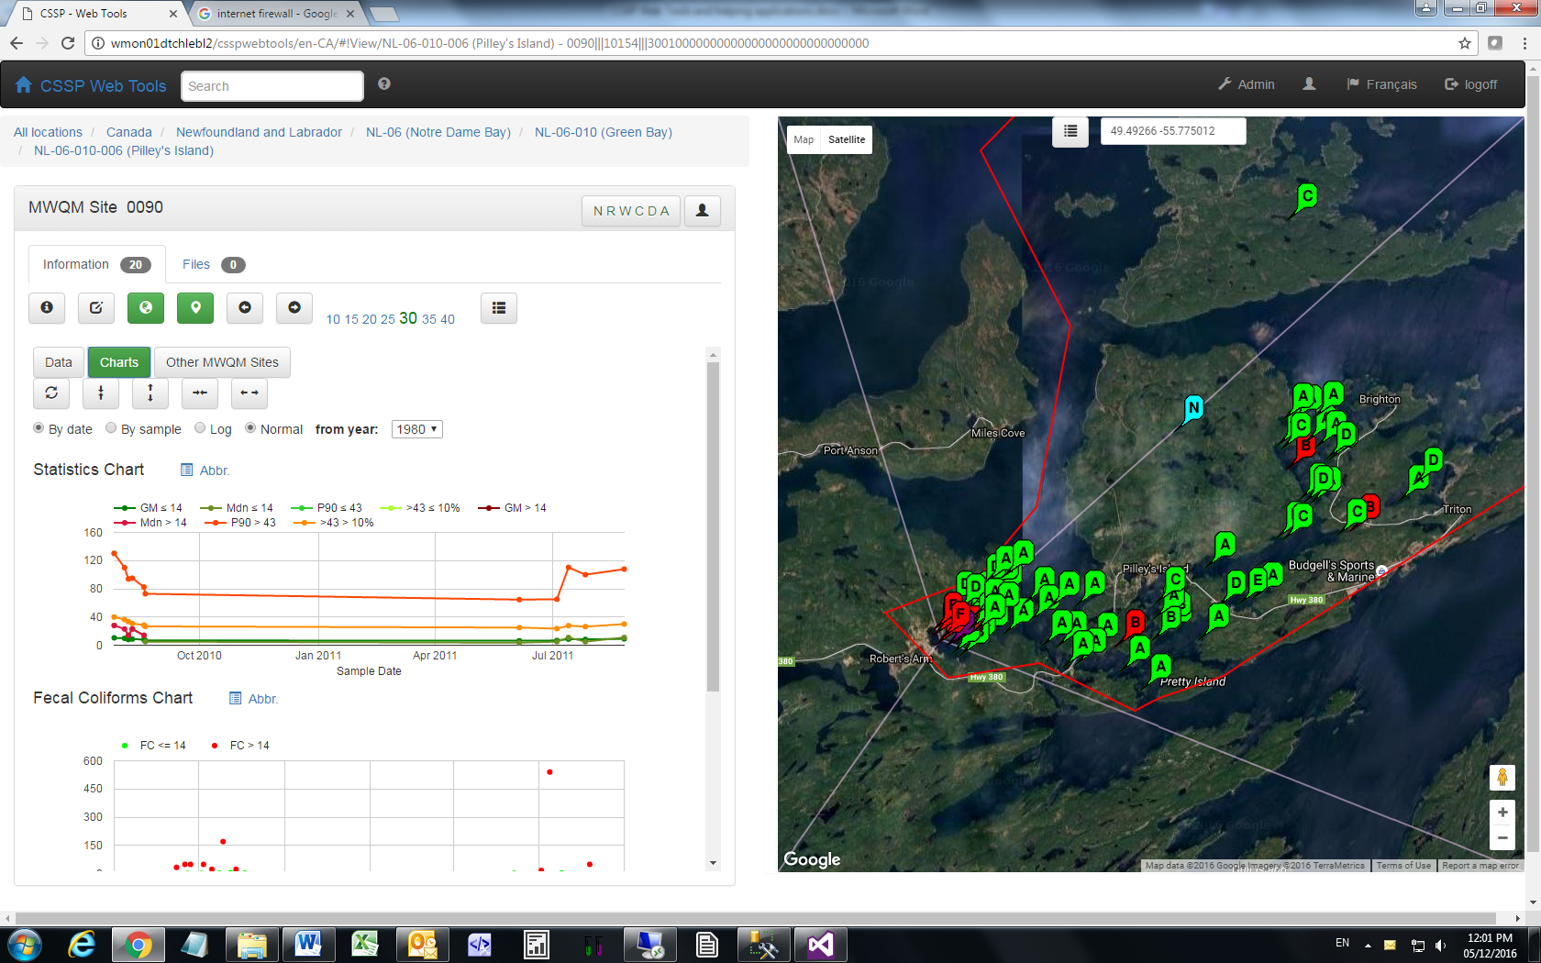

**Detail description:**

* … todo

Appendix B

**CSSPWebToolsTaskRunner** (Background, no user interaction)

Desktop application running in the background and responsible for executing various long tasks sent using CSSPWebTools.

Running inside ECCC firewall.

**Requires:** CSSPWebToolsDBDLL, CSSPLabSheetParserDLL, CSSPReportWriterHelperDLL, CSSPFCFormWriterDLL, CSSPModelsDLL, CSSPEnumsDLL

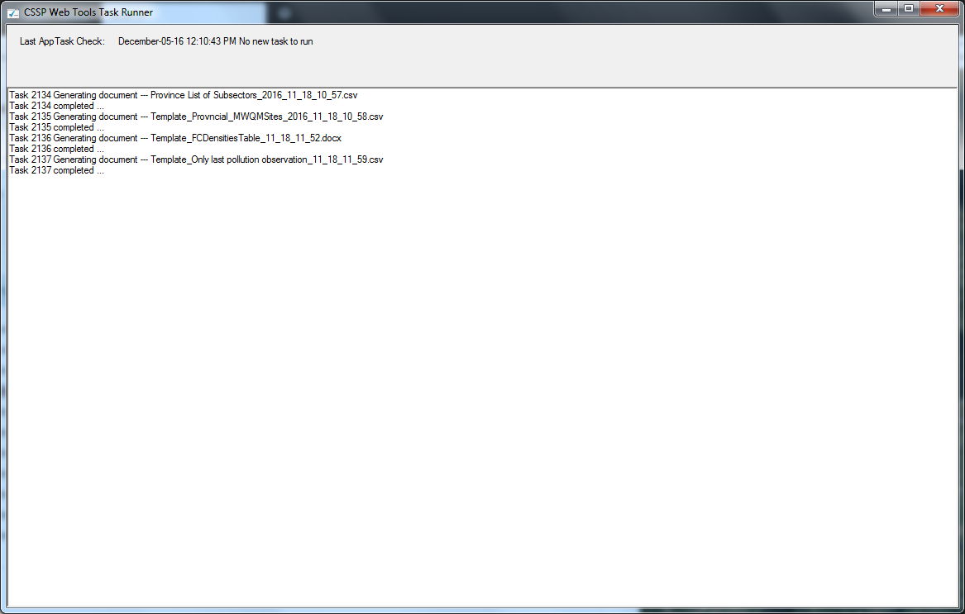

**Detail description:**

* … todo

Appendix C

**CSSPReportWriterHelper** (User interaction)

Desktop application responsible for helping users create templates which can them be sent to CSSPWebTools.

Running inside ECCC firewall.

**Requires:** CSSPWebToolsDBDLL, CSSPReportWriterHelperDLL, CSSPModelsDLL, CSSPEnumsDLL

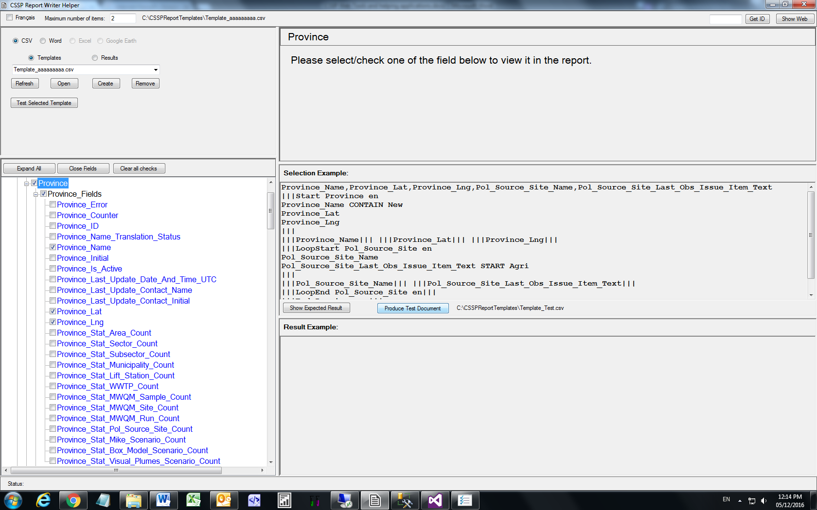

**Detail description:**

* … todo

Appendix D

**CSSPLabSheet** (no visible web page)

Web Site responsible for receiving and storing temporary lab sheets sent using CSSPWQInputTool

Running outside ECCC firewall.

**Requires:** CSSPLabSheetParserDLL, CSSPModelsDLL, CSSPEnumsDLL

**Detail description:**

* … todo

Appendix E

**CSSPWQInputTool** (User interaction)

Desktop application responsible for managing and pushing lab sheets information to CSSPLabSheet

Can run inside and outside ECCC firewall.

**Requires:** CSSPLabSheetParserDLL, CSSPFCFormWriterDLL, CSSPModelsDLL, CSSPEnumsDLL

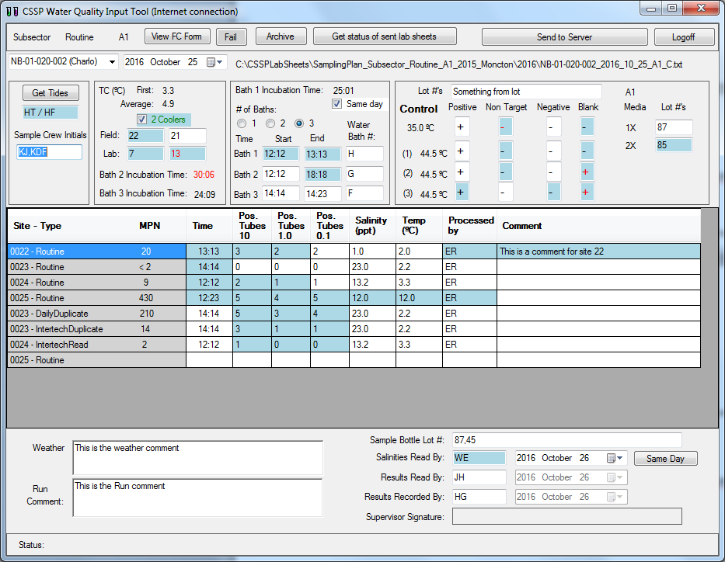

**Detail description:**

* … todo

Appendix F

**TestingPolSourceGrouping** (User interaction)

Desktop application responsible for managing pollution source expert system which is managed by filling an Excel spreadsheet

Can run inside and outside ECCC firewall.

**Requires:**

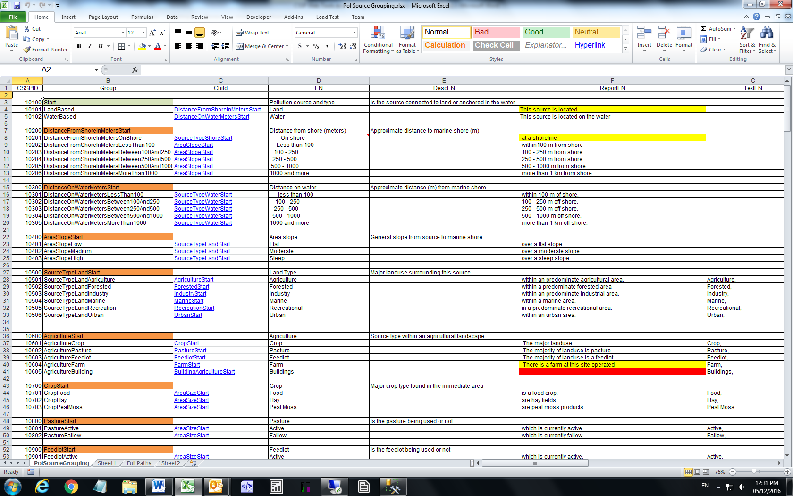

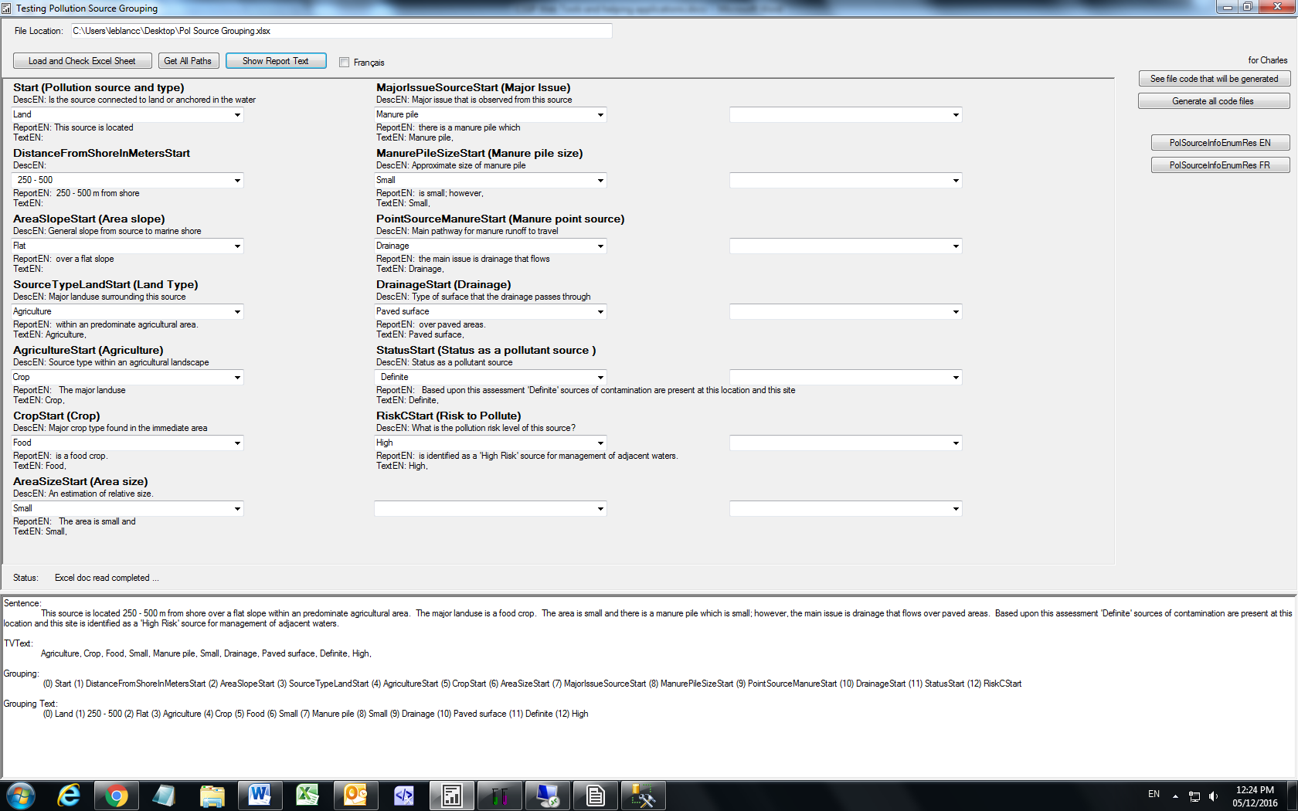

**Detail description:**

* … todo